PROOF OF LIFE

NAME:_______________________________________________
Example: SGT JUAN DIGO DELA CRUZ JR PN(M) (Ret.)
(Rank, First Name, Complete Middle Name, Last Name, BOS)
BIRTHDAY: ______________________________
ADDRESS: _____________________________________________ _______________________________________________________
AGE: ___________________________________
CELLPHONE/LANDLINE NO.:_______________
SIGNATURE: ________________________

________________ ______________
Left Thumb mark Right Thumb mark
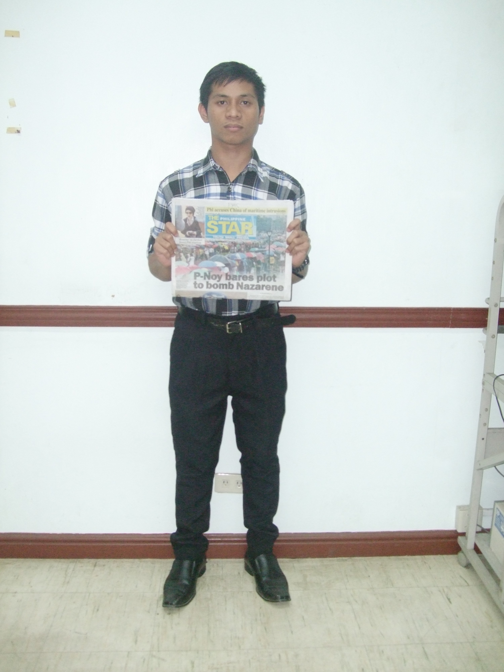

PICTURE HOLDING LATEST NEWSPAPER
Attach:
  - Back to back photocopy of AFP Pensioners I.D.
  - Front Page of used current newspaper
  - Photo copy of pensioner’s passport ( If travelled/went out of the country)
Mail to:
Chief, AFP Finance Center
Camp General Emilio Aguinaldo
Quezon City

